**Project Design Phase-II**

**Data Flow Diagram & User Stories**

Date

12 October 2022

Team ID

Project Name

PNT2022TMID42403

Project - Intelligent Vehicle Damage

Assessment and Cost Estimator for Insurance

Companies

Maximum Marks

4 Marks

**Data Flow Diagrams:**

A Data Flow Diagram (DFD) is a traditional visual representation of the information flows within a system. A neat and clear DFD can depict the right

amount of the system requirement graphically. It shows how data enters and leaves the system, what changes the information, and where data is

stored.

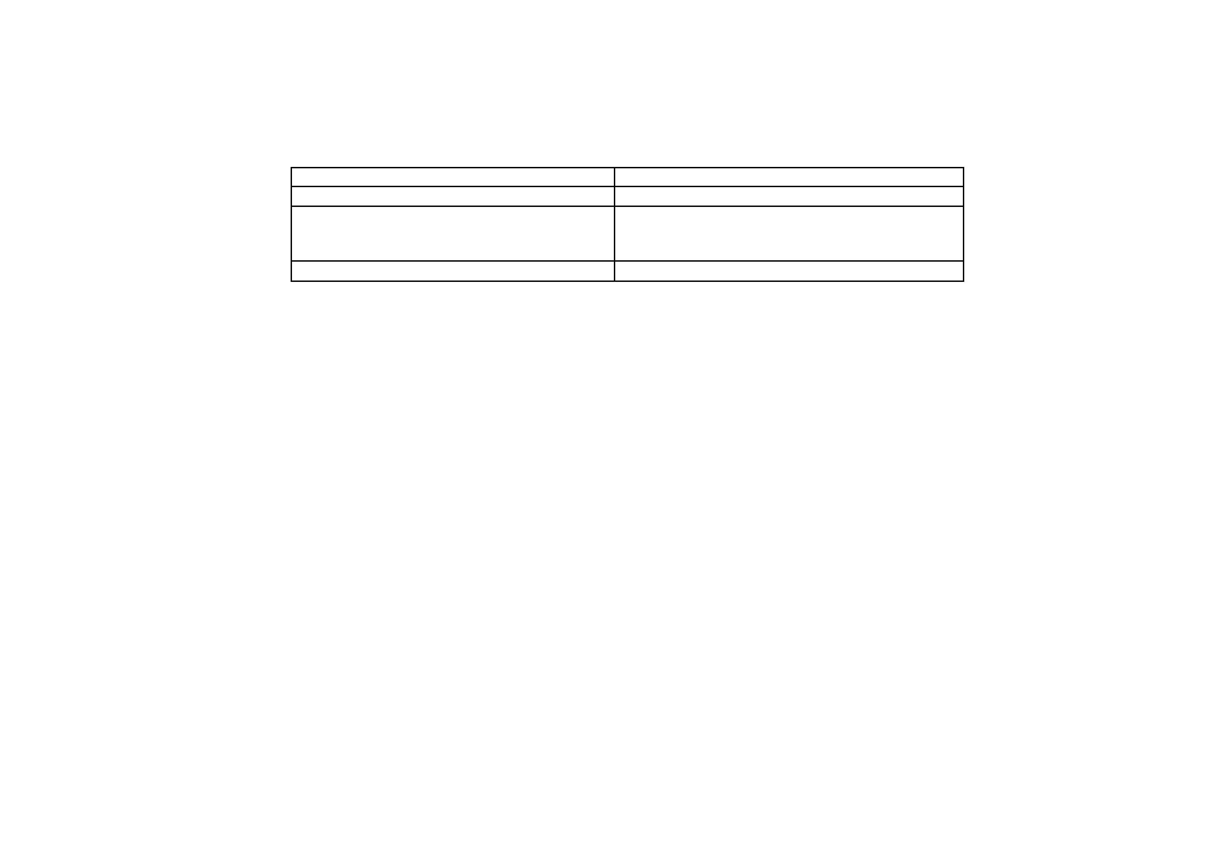

**User Stories**

Use the below template to list all the user stories for the product.

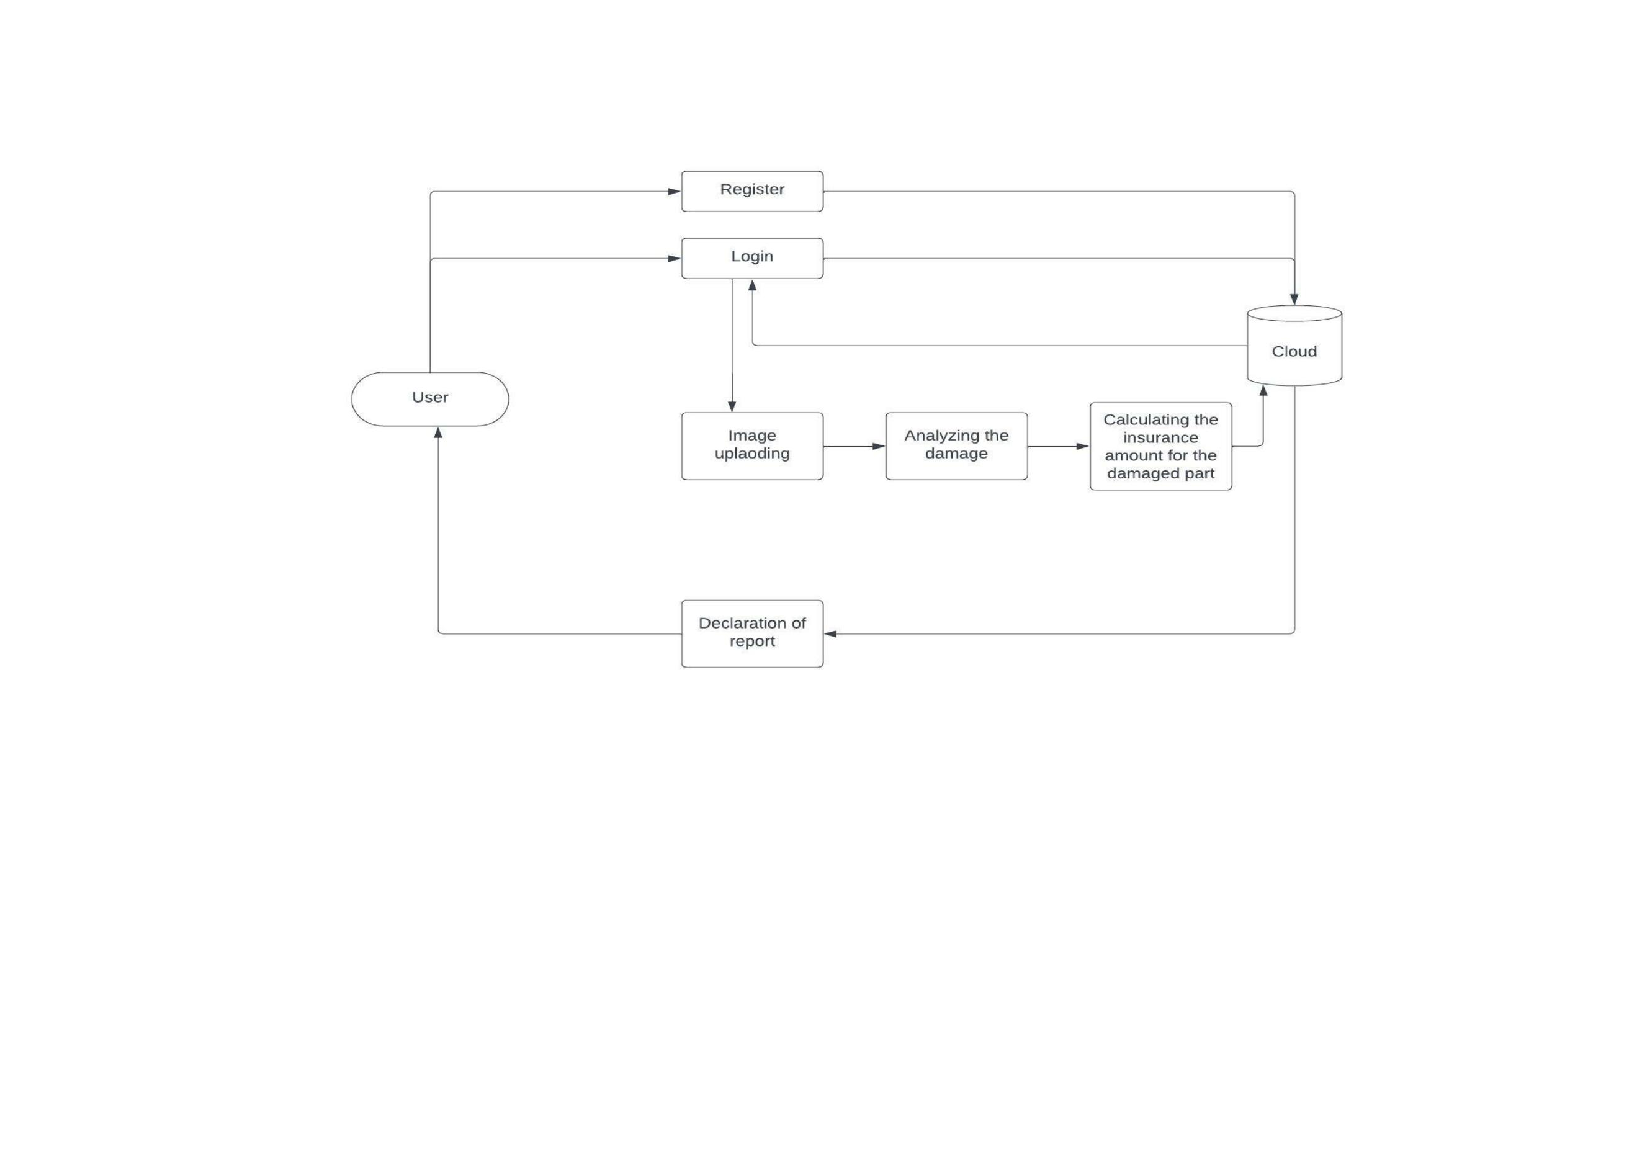

**User Type**

**Functional**

**Requirement**

**(Epic)**

**User Story User Story / Task**

**Number**

**Acceptance criteria**

**Priority**

**Release**

Customer

(Mobile user)

Registration

USN-1

As a user, I can register for the application by

entering my email, password, and confirming

my password.

I can access my account / High

dashboard

Sprint-1

Customer

Details

Customer Uses Dashboard

Login

USN-2

USN-3

As a user, I will receive confirmation email

once I have registered for the application

As a user, I can register for the application

through Facebook

I can receive confirmation

email & click confirm

I can register & access the Low

dashboard with Facebook

Login

High

Sprint-1

Sprint-2

Customer

options

Customer’s

mandatory work damaged image

Customer value Cost details

based on damage

Customer Care

Executive

Gmail access

Uploading car

USN-4

USN-5

USN-6

USN-7

USN-8

As a user, I can register for the application

through Gmail

As a user, I can log into the application by

entering email & password

It gives the insurance cost based on the

damage

We provide excellent user assistance for the

application for insurance

I can sign up and access

the details via Gmail

I can scan the complete

vehicle through camera

I can get estimated

insurance cost price

I can get effective

customer support

I can get effective

customer support

Medium

Sprint-2

Sprint-3

Sprint-3

Sprint-4

Sprint-4

High

High

Effective

Medium

High

customer support

To complete the

customer work

Administrator

We will respond to customer needs in a good

way without mistakes.

